IDEATION PHASE – DOCUMENT 2:

DEFINE PROBLEM STATEMENT
Date | 05 November 2025
Team ID | NM2025TMID03595
Project Name | Garage Management Application
Maximum Marks | 4 Marks

Title: Problem Definition for “Garage Management Application – A Salesforce-Based Workshop Automation System”

1. Objective
The main objective of this document is to define the key operational challenges faced by automobile garages and describe the need for a digital solution. This step transforms our brainstorming insights into a structured problem statement, highlighting how a Salesforce-based Garage Management System can improve service efficiency, reduce human errors, and enhance customer satisfaction.

2. Context and Background
Many small and medium-sized automobile garages still rely on manual processes for managing customers, appointments, and billing. This traditional system leads to:
- Misplaced or incomplete service records
- Confusion in scheduling and tracking appointments
- Errors in calculating service costs and generating bills
- Delays in quality checks and payment updates

The lack of an integrated digital platform makes it difficult for garages to monitor performance or maintain transparency with customers.
By leveraging Salesforce CRM, the project aims to digitalize these operations — creating a centralized, automated, and efficient platform for both staff and customers.

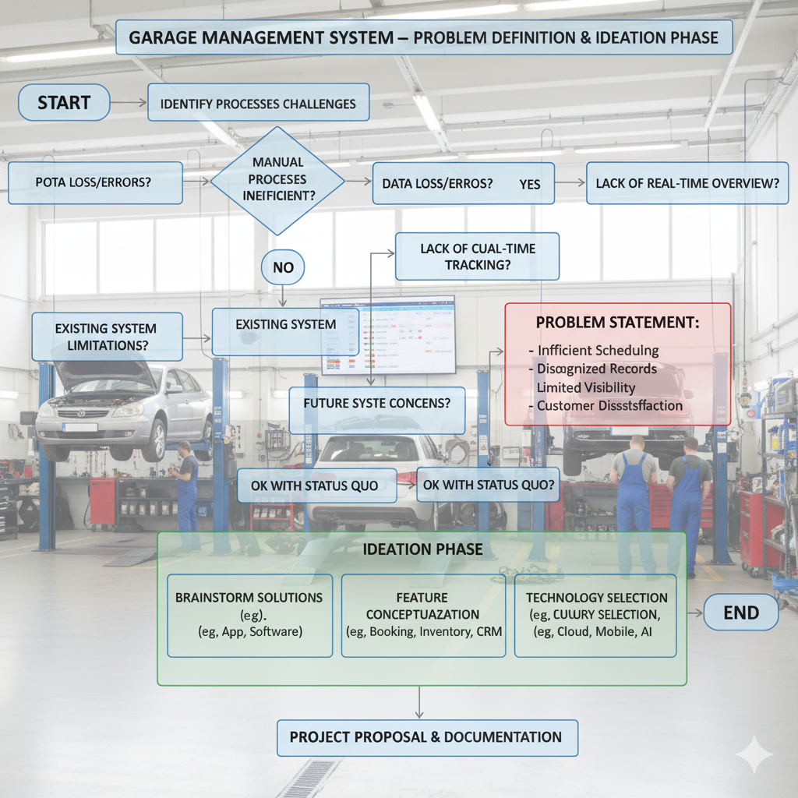

3. Problem Observation
Through observation and interviews with local garage owners and mechanics, the following issues were identified:
- Manual Record Management: Customer and service details are often written on paper, leading to data loss.
- Inefficient Appointment Scheduling: Overlapping or missed bookings due to lack of proper tracking.
- Inaccurate Billing: Service costs are calculated manually, causing errors and disputes.
- Poor Workflow Visibility: Managers cannot easily monitor service progress or employee performance.
- Limited Customer Engagement: Feedback collection is irregular, making it hard to assess service quality.
These observations clearly indicate the need for a cloud-based system that automates and organizes garage operations.

4. Core Problem Statement
“There is no centralized and automated system to manage garage operations such as customer details, appointments, service tracking, and billing — leading to inefficiency, errors, and poor customer experience.”

This issue can be effectively resolved by building a Salesforce-based Garage Management Application that automates the workflow, enhances coordination, and ensures transparency.

5. Project Goals
The Garage Management Application is developed with the following goals:

- To digitalize all garage activities using Salesforce CRM.
- To automate appointment booking, service tracking, and billing using Flows and Triggers.
- To ensure accurate service amount calculation based on selected maintenance options.
- To enable real-time visibility of garage performance through Reports and Dashboards.
- To collect customer feedback and maintain quality assurance records digitally.

6. Scope and Constraints
In-Scope:
- Appointment and service management
- Billing and feedback automation
- Report and dashboard generation
- User roles and access control (Manager, Salesperson, Technician)
Out-of-Scope:
- Integration with third-party payment gateways
- Vehicle spare parts inventory management (future enhancement)
- AI-based fault detection
Constraints:
- Internet access is required to use Salesforce services
- Limited Salesforce user licenses
- Dependence on user training for smooth adoption

7. Technical Relevance
Salesforce provides a low-code, cloud-based platform ideal for CRM and process automation.
The project utilizes:
- Custom Objects: To store Customer, Appointment, Service, and Billing details
- Validation Rules and Triggers: To ensure data accuracy and automate workflows
- Flows: To update related records dynamically
- Reports & Dashboards: For performance tracking and data visualization
- Profiles & Roles: For defining access levels and data security
This makes the system technically sound, scalable, and efficient for real-world implementation.

8. Success Criteria
The success of Garage Management is measured using four key performance indicators (KPIs):
KPI | Measurement Goal | Method of Evaluation
 | 40–50% faster process completion | Time analysis before & after automation
  Service Efficiency
Error Reduction | 90% decrease in manual entry mistakes | Validation & record logs
Customer Satisfaction | 80% positive feedback | Feedback reports
Transparency | 100% data traceability | Reports and dashboards

9. Expected Impact
The system is expected to:
- Improve overall operational efficiency of garages.
- Reduce human errors and service delays.
- Provide real-time transparency to both staff and customers.
- Establish a scalable framework that can be adopted by multiple garage branches.

